English II Fall 2011

Mrs. Morrow
dsmorrow@wsfcs.k12.nc.us
dmorrow5@earthlink.net

Welcome to English Two!

This is a semester in which we’ll be working together on writing—lots of writing. We will read together as well, including essays, stories, poetry, and at least two books that you’ll have an opportunity to choose, but throughout the semester we’re going to be a doing a lot of writing.

Don’t worry if you’re not already a strong writer. What will help you succeed—and what has helped students in the past who have been successful—is an openness to trying new things, a willingness to put forth effort, and be persistent with that effort, a willingness to take risks, and a willingness to ask questions when you don’t understand. One of my favorite things to hear at the end of a semester is, “I never really thought of myself as a writer until I took English II.” My hope is that by the end of the semester each one of you will see yourself as a writer.

Please feel free to talk to me if at any point during the semester if you encounter problems or questions about the class—or if you just have a good idea for something you’d like to try. I’m available before school for conferences and tutoring, as well as afternoons by appointment—or whenever you can find me in my office. (Sometimes the door is partially closed. Feel free to knock.) You are also welcome to email me questions and I’ll make every effort to respond within a reasonable amount of time.
STRUCTURE AND EXPECTATIONS FOR ENGLISH II

- Be On Time, Seated, and Prepared to Work at the beginning of class—9:05 or 10:30. Being on time allows us to use the whole class period for the work of this class. (Please use the restroom and get drinks before coming to class. You may leave the class for a restroom emergency—but those with more than one restroom emergency per quarter lose drink privileges during class.)
- Quiet Writing Is Quiet. We’ll write for at least some part of the class period nearly every day. During this writing time we’ll maintain quiet so that people can concentrate.
- Class Discussion Requires Everyone’s Participation. During whole-class discussion one person speaks at a time and listening and asking thoughtful questions is a key component of participating. Respect for the person speaking is a high priority in my classes.
- Deadlines are Deadlines. Work is due on the due date. Late work will be accepted, but will decline by one letter grade for each class period late. Late work will also make you eligible for make-up work sessions on Friday afternoons. If you have unusual circumstances, please talk to me prior to the due date.
- Supplies. You will need 2 bound composition books, notebook paper, a one half or one inch binder for your writing portfolio, and something to write with. Please see me if you are having any trouble gathering these supplies.
- Grading. I grade on process—how well you participate in the activities of the class. I also grade on products—how well you do on the papers, projects and essays that will be a part of this class. Grades will be calculated this way:
- 20% Daybook—see attached.
- 30% Participation, portfolio & quizzes. Participation involves coming to class prepared, keeping engaging in classroom activities, and doing quality work in class. See rubric.
- 50% Papers & Tests & Projects
- Grading scale is: 93-100 A for excellent work that exceeds expectations; 85-92 B for proficient work that meets expectations; 77-84 C for work that is partially proficient; 68-76 D for barely proficient work; 50-68 failing work.
- The Importance of Honesty. It is important in this class that the work you turn in be your own work and that any sentences or phrases you use from books, articles or websites, be quoted and cited. We will review plagiarism together.
- Portfolio. You are required for this class to place all your papers, with drafts, in a binder that you may keep in a cabinet in the room. The most important thing for you to know at the outset is to save everything electronically, including drafts, and to date everything. After you complete a draft—of anything—I’d strongly suggest emailing it to yourself so that you will have a copy of everything online. This portfolio will be checked periodically and will be part of your final exam.
- What to Bring. Plan to bring your daybook and the book you’ve chosen for independent reading to class every day. These are your 2 options for activities if you complete work early. Homework from other classes is not a good option in this class and will negatively affect your participation grade. Your literature textbook isn’t needed unless I tell you ahead of time.

THE DAYBOOK or WRITER’S NOTEBOOK

The daybook or writer’s notebook is a bound composition book you will use for writing practice this semester. The point? A safe rule-free place for you to practice your writing. A place to get practice connecting your mind and your hand. A place to get more fluent at getting your thoughts out onto the page.

I’m not looking for correct spelling or grammar. What I am looking for is effort—and filled pages. A full notebook (80 pages both sides with quality work) earns an A at the end of the quarter. 50 quality pages both sides earns a B. 35 a C. If you write something private simply fold the page over. I will check daybooks periodically for a participation grade.
WHAT WORKS . . .
Freewriting
Brainstorming
Lists
Poems
Stories
Drafting papers
Original song lyrics
Thinking on the page
English class notes
Writing exercises we do in class
Reflection
Expressing creativity
Drawings here and there, especially if they’re accompanied by writing.
Handouts from English class
Starting that novel you’ve been meaning to write
Pasting or copying song lyrics or poems or paragraphs and writing responses to them or using them to inspire your own writing
Speculating on the origin of the universe

WHAT DOESN’T WORK . . .
Homework from other classes
Disrespect—of anyone
Gossip—(although gossip, which is really just stories, could become a catalyst for fiction)
More than ¼ of daybook made up of pasted or borrowed work (such as handouts, poetry & song lyrics by other writers, quotes) or drawings.

The majority of the daybook should be you as a writer.

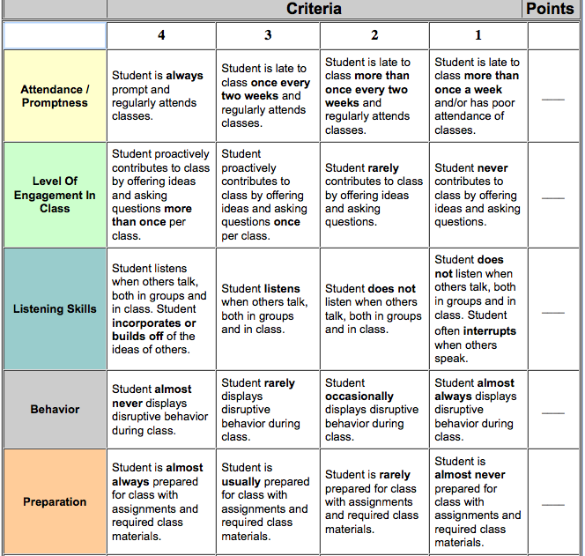

http://teachers.teach-nology.com/cgi-bin/classpar.cgi

