**MATH II**

**Name: ___________________Date: ____________ Period___Classs____**

**Transformational Geometry Note Sheet**

A **transformation** is a change in the __________, _______________, or ______________ of a figure.

A **translation** is a transformation which ____________ each point of a figure the same ____________ and in the same ________________.

The resulting figure after a transformation is called the ___________ of the original figure.

**EXAMPLE 1:**

Δ*ABC* is translated 1 unit right and 4 units up. Draw the image Δ*A’B’C’*.

What are the coordinates of:



*A* (1, -3) 🡪 *A’* _________

*B* (3, 0) 🡪 *B’* _________

*C*  (4, -2) 🡪 *C’*__________

From EXAMPLE 1, *ΔABC* 🡪 *ΔA’B’C’*

As a general rule this translation could be written as

(*x, y*) 🡪 (*x* + ___, *y* + ___ ).

**EXAMPLE 2**

Δ*JKL* has coordinates *J* (0,2), *K* (3,4), and *L* (5,1).

a) Draw Δ*JKL*. b) Draw the image Δ*J’K’L’* after a translation of 4 units to the left and 5 units

up. Label the triangle.What are the coordinates of:



*J*  (0, 2) 🡪 *J’* _________

*K* (3, 4) 🡪 *K’* _________

*L* (5, 1) 🡪 *L’*__________

Rule: (*x*, *y*) 🡪 ( , )

Tell me more about this figure, is it

congruent or similar? Explain how you know.

|  |  |  |
| --- | --- | --- |
|  | Add | Subtract |
| *x* coordinate |  |  |
| *y* coordinate |  |  |

Translation Location

**EXAMPLE 3:**

Write a general rule which describes the translation shown below. Δ*LMN*  is the original triangle.



(*x, y*) 🡪 ( , )

**EXAMPLE 4:**

a) Graph points *T*(0,3), *U*(2, 4) and *V*(5, -1) and connect the points to make a triangle.



b) Translate Δ*TUV* using the rule (*x, y*) 🡪 (*x* - 3, *y* - 1).

c) In words, describe what the rule is asking you to do.

_________________________________________

d) Draw the image Δ*T’U’V’*.

e) Identify the coordinates of Δ*T’U’V’*.

*T’ U’ V’*

f) Using the image of Δ*T’U’V’* perform an additional translation

using the rule (*x, y*) 🡪 (*x* + 3, *y* - 3). State the new coordinates of Δ*T”U”V”.*

Is this new image congruent or similar to the original figure?__________________________

**Practice**



1 a) Use arrow notation to write a rule for the given

translation. __________________

b) Graph and label the image after the translation.

c) Name the coordinates of the image.

A’ _____________ B’ _____________

C’ _____________ D’ _____________

2 a) Use arrow notation to write a rule for the given

translation. __________________

b) Graph and label the image after the translation.

c) Name the coordinates of the image.

A’ _____________ B’ _____________

C’ _____________ D’ _____________



In questions 3 and 4 below, use arrow notation to write a rule that describes the translation shown on the graph.



**3)** **4)**



**5)** MULTIPLE CHOICE: Write a description of the rule .

**(a)** translation 7 units to the right and 4 units up

**(b)** translation 7 units to the left and 4 units down

**(c)** translation 7 units to the right and 4 units down

**(d)** translation 7 units to the left and 4 units up

**Classwork/Homework/More Practice/Graded Work**

**1.** Draw the translation of the triangle *HOT* six units left and one unit down. Label the image *H’O’T’*. Is the image similar or congruent? How do you know?



**2.** Find the translation of the quadrilateral *WXYZ* under the rule.



Use the grid below to answer questions 3 through 5.



**3.**Find the rule to describe the translation from point *A* to point *B*.

**4.**Find the rule to describe the translation from point *C* to point *D*.

**5.**Find the rule to describe the translation from point *E* to point *A*.

**6.**Quadrilateral *ABCD* is plotted on the grid below. On the graph, draw the translation of polygon *ABCD* eight units to the left and seven units down. Label the image *A’B’C’D’*. On the lines below, explain how you determined the location of *A’*. ____________________________________________________________



**7.** Quadrilateral *PQRS* is plotted on the grid below.

On the graph, draw the translation of polygon *PQRS* three units to the left and four units down. Label the image *P’Q’R’S’*. Now create polygon *P”Q”R”S”* by translating polygon *P’Q’R’S’* using the rule . What will be the coordinates of point *Q”*? ***Answer ______________***On the lines below, write a single translation rule from polygon *PQRS* to polygon *P”Q”R”S”*.

________________________________________________________



.

8. Graph each figure and the image under the given translation. Name the new coordinates.

a.  with vertices L(-3, -1),

I(-1, 4), and P(2, 2) under the translation .

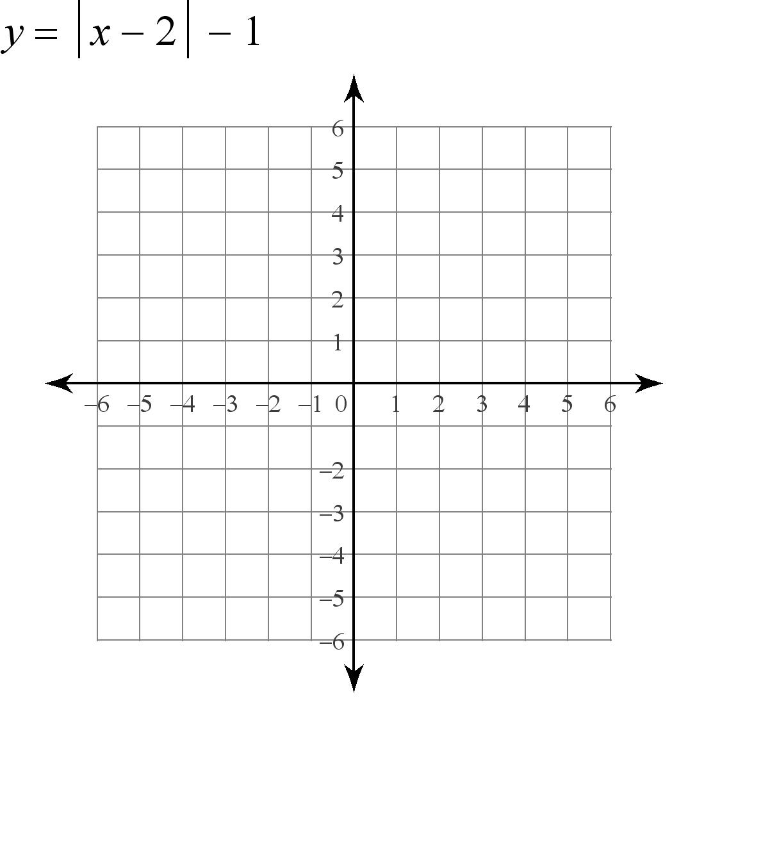

b. Quadrilateral DUCK with vertices D(2,2), U(4, 1), C(3, -2), and K(0,-1) under the translation .



c.  with vertices R(-4, -1), S(-1, 3), and T(-1, 1)under the translation 



L’_____

I’_____

P’_____

D’_____

U’_____

C’_____

K’_____

R’_____

S’_____

T’_____

d. Quadrilateral BAND with vertices B(-3, -3), A(2, -3), N(5, 1), and D(1, 1) under the translation .

e. Pentagon MOUSE with vertices M(-1, -2), O(2, -1), U(5, -2), S(4, -4), and E(1, -4) under the translation .

f . Quadrilateral MATH with vertices M(4, 1), A(2, 4), T(0,6), and H(1,2) under the translation .



B’_____

A’_____

N’_____

D’_____

M’_____

O’_____

U’_____

S’_____

E’_____

M’_____

A’_____

T’_____

H’_____