Table of Contents
Mission Statement 2
Rationale 2
Data Sources 3
Rationale about weeding 4
Rational concerning e-books and databases 4
Special Focus 4
Technology Support Items 5
2013-2014 6
2014-2015 7
2015-2016 8
2016-2017 9
2017-2018 10
Works Cited 12

Mission Statement
The mission of the Smith Farm Elementary School Media Center is to support the creation of life-long, global learners and leaders who are effective seekers and users of information.

Rationale
This collection management plan exists to support the mission and vision of Smith Farm Elementary School. Our starting collection was created taking into consideration: NCDPI’s IMPACT guidelines, NC Essential Standards, Common Core, and Smith Farm Elementary School’s unique needs as a Global School Network and Spanish Dual Language Immersion School. IMPACT guidelines suggest a plan to “cycle throughout the entire media and technology collection within five years so that at any given time, time-sensitive resources are within five years of currency.”

Data Sources
Collection Analysis
We currently have 10,102 titles in our collection, not including Supplemental Instructional Resources.
Our collection meets the Minimum Guidelines of North Carolina's IMPACT
- Throughout the collection, the average date of publication is 2008 or 6 years old.
- Overall our books-per-student ratio is 10 according to our maximum 800 student capacity.
- In reality our enrollment is around 400 students, so our books-per-student ratio is 25, putting us into the Outstanding IMPACT category.
IMPACT Collection Guidelines are as follows:
- Outstanding = 20 books per student and an average age of 10 years
- Developing = 15 books per student and an average age of 12 years
- Minimum = 10 books per student and an average age of 16 years
For more information on IMPACT: Guidelines for North Carolina Media and Technology Programs, go to: http://www.ncwiseowl.org/Impact/default.htm.
The average age of our Dewey 500s is 2010, the recommended average age is 2005.
The average age of our Dewey 600s is 2011, the recommended average age is 2007.
The oldest areas are the 300s, 400s and 800s

Rationale about weeding
Why do we weed?
- Books become inaccurate and/or outdated
- Books get damaged
- Books that may have been popular at one time become outdated and there simply isn’t room on the shelves to keep everything.
“Outdated collections do not get that way overnight, neither can they be fixed overnight.”
“The ongoing weeding or de-selection of materials that are no longer relevant or accurate is an essential component of collection development and should be done as systematically and objectively as possible.” (IMPACT)

Rational concerning e-books and databases
E-books purchased with mulit-user licenses through the media center provide:
- not just class sets of a book, but a school set of a book
- books that are available to students with access 24/7
- many books that can “read aloud” to students
- books that can be used in instruction on Promethean boards
“Checking out books from the school library will start to take on new meaning as more teachers and parents insist on 24/7 access in school and at home.” (Guernsey)

Special Focus
Our Spanish Dual Language Immersion program and status as a Global Schools Network member necessitate a special focus on materials with a global theme and Spanish language materials.

Technology Support Items
While our media center may not need additional technology for the next 5 years, replacement of any components that break should be taken into consideration.
The technology available in the media center consists of:
- 1 laser printer
- 4 desktop computer search stations
- 16 desktop student computers
- 2 desktop circulation computers
- 1 desktop office computer
- 1 Promethean solution: desktop, projector, Promethean board, 32 activ expression 2s, 1 activslate
- 1 MediaCast cart
- 8 digital cameras
- 8 “flip” video cameras
- 1 video camera
- 1 spare projector

2013-2014
Weed:
- Damaged items
- Biographies & Science/Technology with major changes
Add:
- Subscriptions
- 5 copies of each E-BOB title
- 2 copies of each NCCBA title
- Subscription to Junior Library Guild
Special Focus:
Technology Support Items:
- Green screen for news show
- Lighting for news show
- Batteries
- Barcode labels

2014-2015
Weed:
- Damaged items
- Biographies & Science/Technology with major changes
- 600s, 000s, fiction, everyone
Add:
- 600s, 000s, fiction, everyone
- Subscriptions
- Requests
- New biographies
- Five copies of each E-BOB title
- New additions to series
- Outstanding/Award winning Fiction, Non-Fiction, and Picture books such as:
- Caldecott Honor and Winning Titles
- Newbery Honor and Winning Titles
- Coretta Scott King Honor and Winning Titles
- Pura Belpré Honor and Winning Titles
- Seibert Honor and Winning Titles
- Geisel Honor and Winning Titles
- NCCBA picture and junior book nominees
Special Focus: Many of the above additions should be made in e-book format to keep our e-book collection growing.
Technology Support Items:
- Technology in need of replacement
- Batteries

2015-2016
Weed:
- Damaged items
- Biographies & Science/Technology with major changes
- 500s, 100s, fiction, everyone
Add:
- 500s, 100s, fiction, everyone
- Subscriptions
- New biographies
- Five copies of each E-BOB title
- New additions to series
- Outstanding/Award winning Fiction, Non-Fiction, and Picture books such as:
- Caldecott Honor and Winning Titles
- Newbery Honor and Winning Titles
- Coretta Scott King Honor and Winning Titles
- Pura Belpré Honor and Winning Titles
- Seibert Honor and Winning Titles
- Geisel Honor and Winning Titles
- NCCBA picture and junior book nominees
Special Focus: Many of the above additions should be made in e-book format to keep our e-book collection growing.
Technology Support Items:
- Technology in need of replacement
- Batteries

2016-2017
Weed:
- Damaged items
- Biographies & Science/Technology with major changes
- 300s, 200s, 700s fiction, everyone
Add:
- 300s, 200s, 700s, fiction, everyone
- Subscriptions
- New biographies
- Five copies of each E-BOB title
- New additions to series
- Outstanding/Award winning Fiction, Non-Fiction, and Picture books such as:
- Caldecott Honor and Winning Titles
- Newbery Honor and Winning Titles
- Coretta Scott King Honor and Winning Titles
- Pura Belpré Honor and Winning Titles
- Seibert Honor and Winning Titles
- Geisel Honor and Winning Titles
- NCCBA picture and junior book nominees
Special Focus: Many of the above additions should be made in e-book format to keep our e-book collection growing.
Technology Support Items:
- Projector bulb (assuming a 3 year life span)
- Technology in need of replacement
- Batteries

2017-2018
Weed:
- Damaged items
- Biographies & Science/Technology with major changes
- 900s, 400s, 800s, fiction, everyone
Add:
- 900s, 400s, 800s, fiction, everyone
- Subscriptions
- New biographies
- Five copies of each E-BOB title
- New additions to series
- Outstanding/Award winning Fiction, Non-Fiction, and Picture books such as:
- Caldecott Honor and Winning Titles
- Newbery Honor and Winning Titles
- Coretta Scott King Honor and Winning Titles
- Pura Belpré Honor and Winning Titles
- Seibert Honor and Winning Titles
- Geisel Honor and Winning Titles
- NCCBA picture and junior book nominees
Special Focus: Many of the above additions should be made in e-book format to keep our e-book collection growing.
Technology Support Items:
- Technology in need of replacement
- Batteries
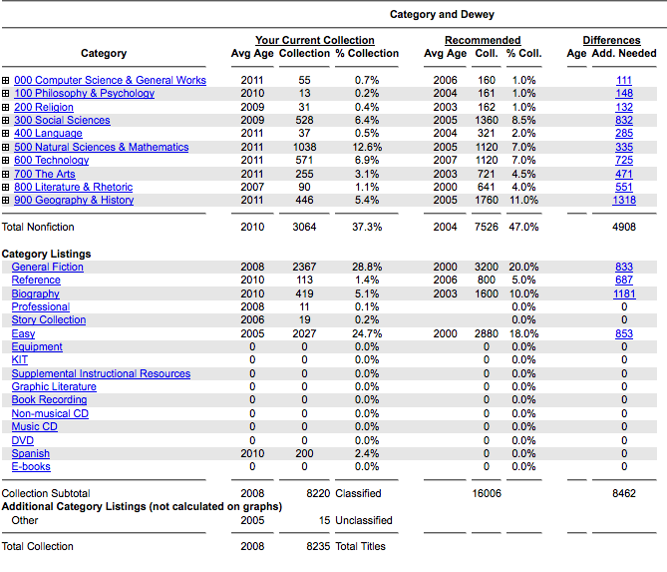

Works Cited
"IMPACT: Guidelines for North Carolina Media and Technology Programs." IMPACT: Guidelines for North Carolina Media and Technology Programs~Table of Contents. Instructional Technology Division, NC DPI, 2006. Web. 15 Feb. 2014. <http://www.ncwiseowl.org/impact/TOC.htm>.
Guernsey, Lisa. "Are Ebooks Any Good?" School Library Journal. School Library Journal, 7 June 2011. Web. 15 Feb. 2014. <http://www.slj.com/2011/06/books-media/ebooks/are-ebooks-any-good/>.

